DAILY ONLINE ACTIVITIES SUMMARY

|  |  |  |  |  |  |  |  |
| --- | --- | --- | --- | --- | --- | --- | --- |
| Date: | 18-05-2020 | | | | Name: | GUDUGUNTI ANIRUDH | |
| GUDUG | 4th A | | | | USN: | 4AL18CS023 | |
| Online Test Summary | | | | | | | |
| Subject | | Complex analysis, Probability and Statistical methods(18MAT41) | | | | | |
| Max.  Marks | | 30 | | Score | | Not yet declared | |
| Certification Course Summary | | | | | | | |
| Course | Python in ML | | | | | | |
| Certificate Provider | | | Great learning academy | Duration | | | 2hrs |
| Coding Challenges | | | | | | | |
| Problem Statement: Two java programs and two C programs | | | | | | | |
| Status: Executed | | | | | | | |
| Uploaded the report in Github | | | | Yes | | | |
| If yes Repository name | | | | https://github.com/Anirudh23-23/Daily-progress | | | |
| Uploaded the report in slack | | | | Yes | | | |

Online Test Details: (Attach the snapshot and briefly write the report for the same)

18MAT41 test was scheduled from 9:30am to 10am and the scores are not yet received .The portion for the IA wad 4th module there were 30 question and the time assigned was 30 minutes the question were mcq type.

Certification Course Details: (Attach the snapshot and briefly write the report for the same)

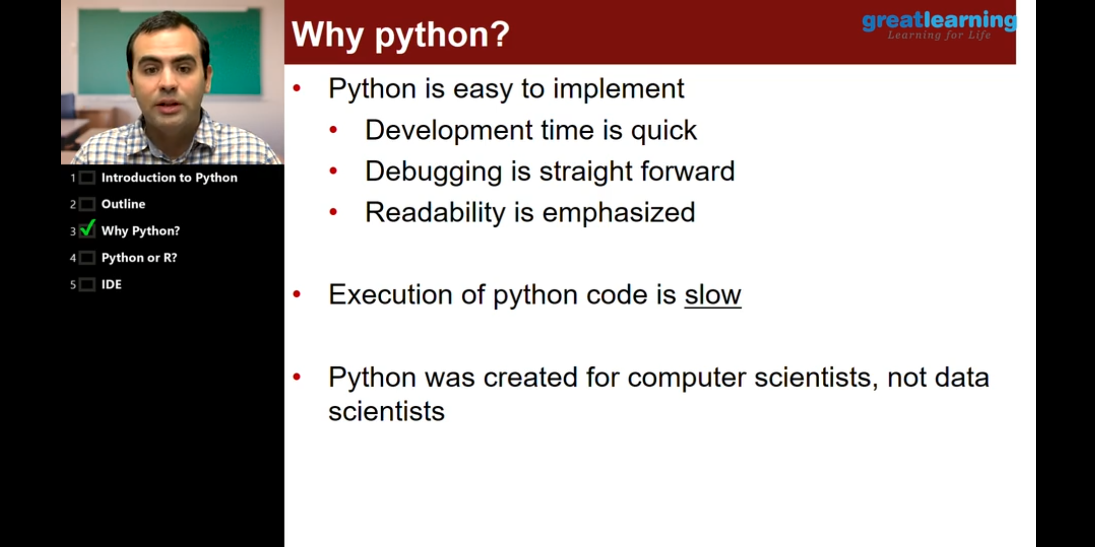

Coding Challenges Details: (Attach the snapshot and briefly write the report for the same)

Program1: Anagram program in c language and I uploaded the program in github

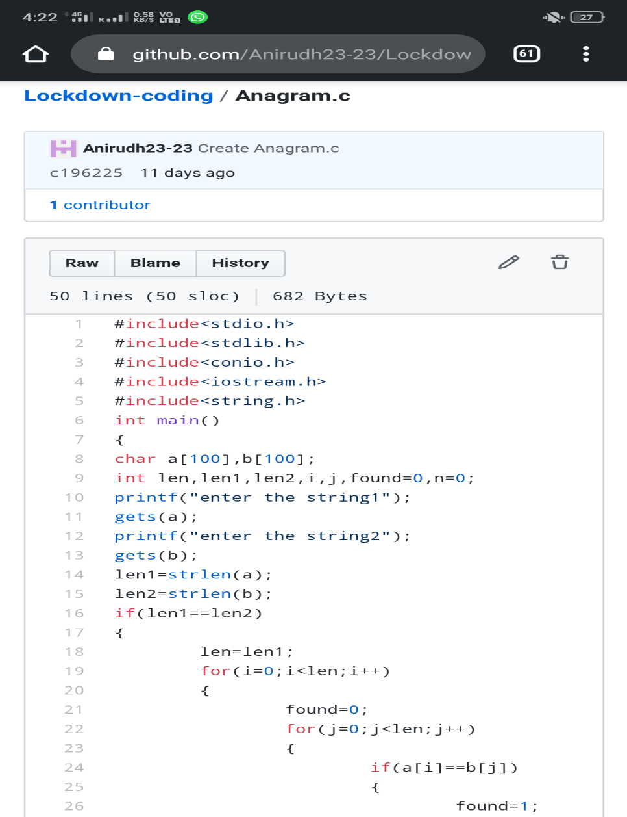

Program2:Triplet program in c language and I uploaded the program in github

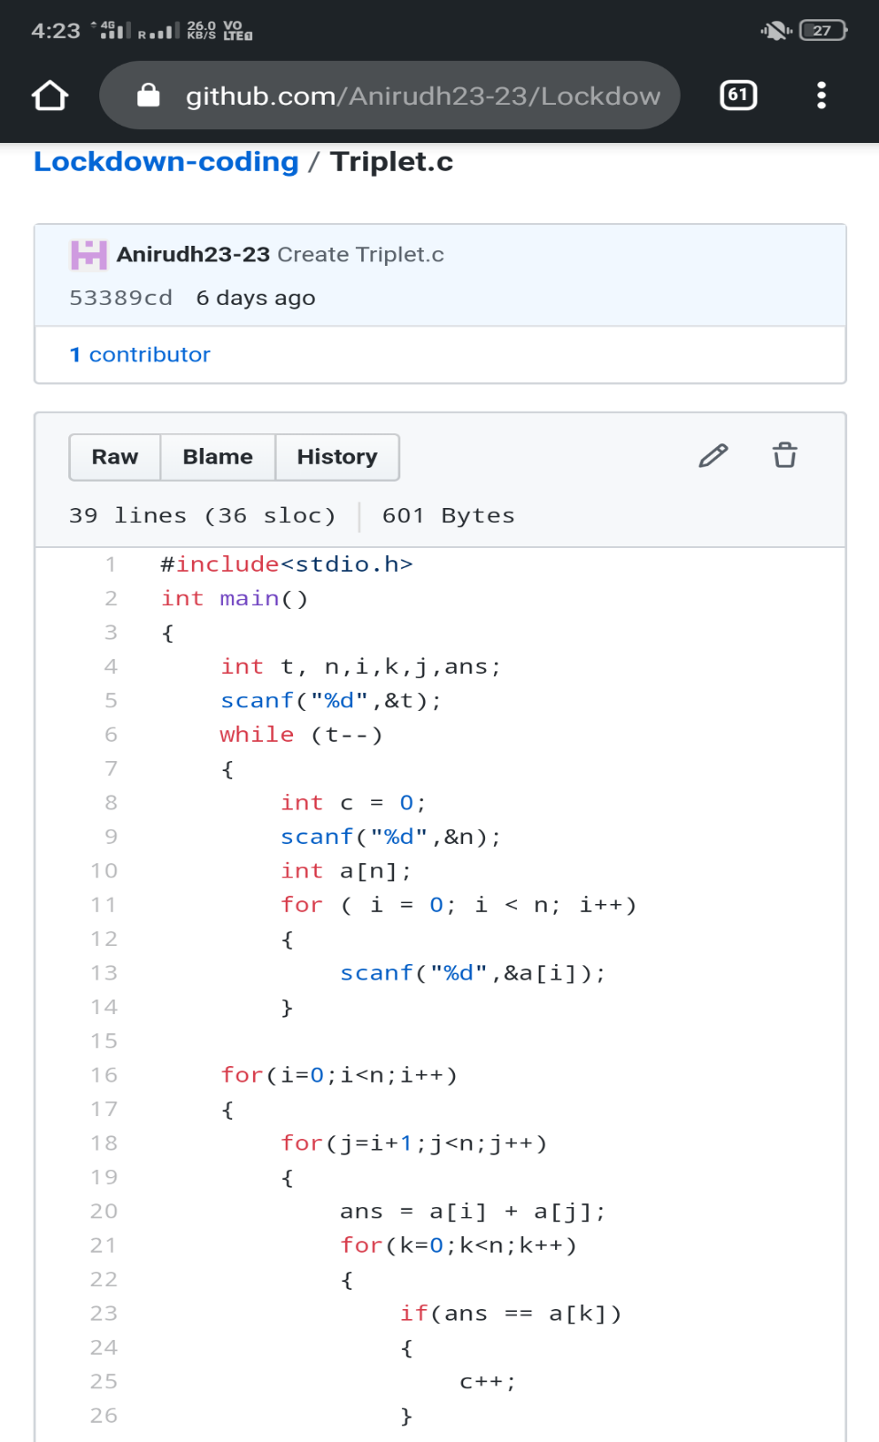

Program3: character count program in java language

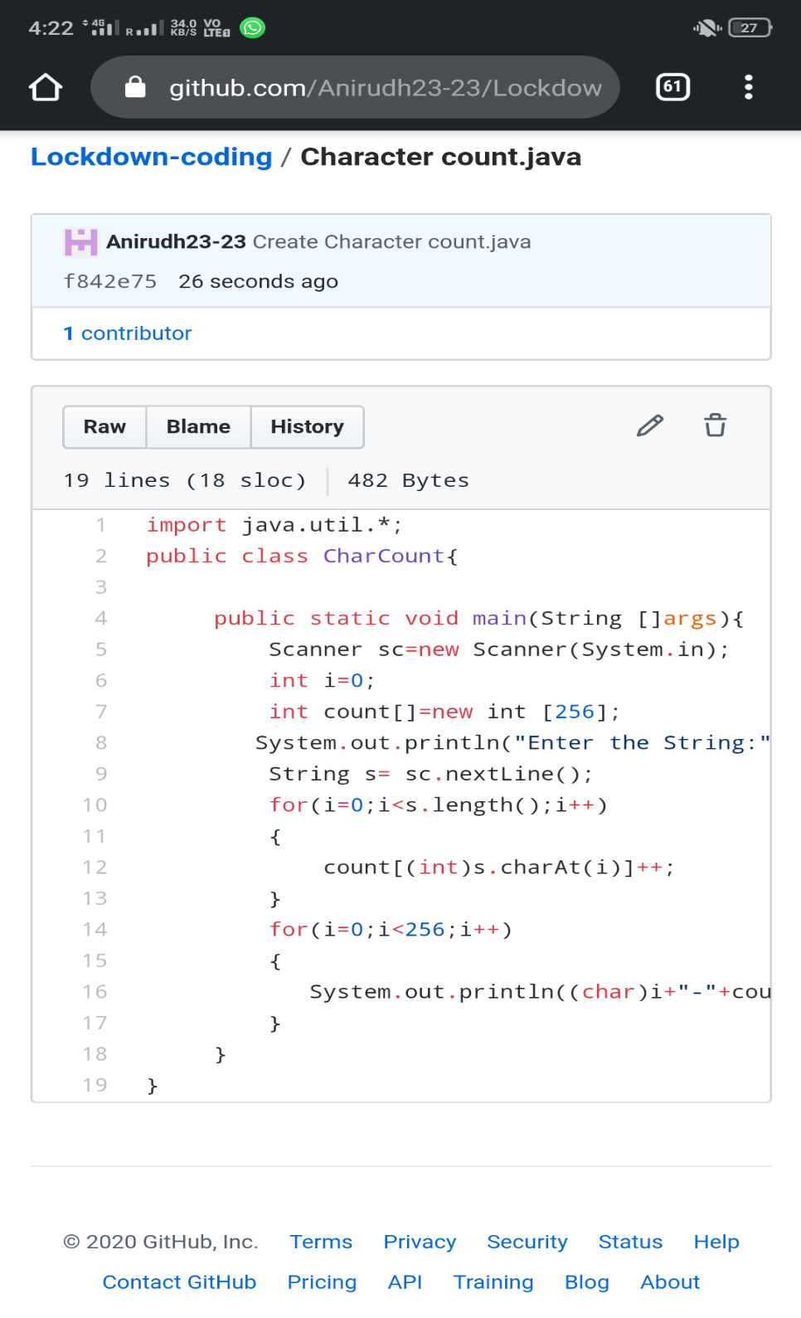

Program4: OddEven program in java language

